TITLE OF ARTICLE IN ENGLISH, UPPERCASE, SIZE 14 PT, FONT TIMES NEW ROMAN, BOLD, MAX 20 WORDS (Use “Title Text” Style in Styles sub-menu)
First author ^{1*}, Second author ², Third author ³ (without titles)
^{1,2,3}Institution names including Department, Faculty, University
Institution address, City, Post Code, Country
Corresponding author’s e-mail: * xxxxxxx@xxxx.com (Put * symbol for corresponding author)
Article Info | ABSTRACT
Article History: | Write the author's name in Times New Roman font, Bold, 12 pt. font size. While, the institution name, institution address, and corresponding author’s email are written in Times New Roman font, Italic, 10 pt. font size. Put the order number for each author, and put the * symbol for the corresponding author. The abstract should be short, concise, and clear; The Abstract represents short information about a research topic, research method, aim, and result of the research. The title of "ABSTRACT" is written in Times New Roman font, Bold, Italic, 9 pt. font size. The abstract is written in English with a maximum of 300 words using Times New Roman font, Italic, 9 pt. font size. Writing abstracts should avoid differing explanations, citations, tables, graphs, and formulas. Keywords should represent the concept of the article and make the article easier for search engines to find. The titles of “Keywords” and “Article History” are written in Times New Roman, Bold, Italic, 9 pt. font size, while their contents are written in Times New Roman, Italic, 9 pt. font size, with keywords having a maximum number of 6, each separated by a semicolon “;”. The article is written using single-side, A4-sized papers. the length requirement of each manuscript is determined according to its subject area. In Barekeng: Journal of Mathematics and Its Applications, the length of manuscripts is determined based on the subject area of the article. For contributions in Applied Mathematics, manuscripts should consist of 10 to 18 pages, while for contributions in Theoretical Mathematics including Algebra and Analysis the required length is 8 to 18 pages. Articles with more than 18 pages will be charged with additional fee. This article uses the Times New Roman font for both heading and body font. Before writing, make sure your document margins match the margins of this template (Use “Abstract Text” Style in Styles sub-menu).

Received: date month year
Revised: date month year
Accepted: date month year

Available online: date month year

Keywords:
Alphabetic;
Barekeng journal;
Mathematics topic;

 | This article is an open access article distributed under the terms and conditions of the Creative Commons Attribution-ShareAlike 4.0 International License

INTRODUCTION
The research article consists of INTRODUCTION, RESEARCH METHODS, RESULTS AND DISCUSSION, CONCLUSION, ACKNOWLEDGMENT (if any), and REFERENCES (Use “First Heading” Style in Styles sub-menu). The Introduction section provides background or research rationale, problems and insights into problem-solving plans, and the formulation of research objectives (along with expectations about the benefits of the research results). The Introduction section should be accompanied by references/citations as a theoretical basis for the problem of the research, such as writing citations [1], [2], etc. In addition to introducing the topic, the introduction section also relates to current knowledge (state of the art), what has been done, and what needs to be done (Gap analysis). Writing citations or references requires the use of reference management tools such as Mendeley. The results and discussion are presented in an integrated manner and reviewed from various related previous theories. The contents of the manuscript from the introduction to the conclusion use line spacing 1.0. The research article ends with a conclusion and acknowledgment (if any). The conclusion is presented in an essay or numbering.
The font type used within the paragraph of the article text is Times New Roman, with 11 pt font size, and line space of 1.0. Spacing after a paragraph uses 6 pt., single-line space. Section titles are written using capital letters, Times New Roman font, Bold, 11 pt font size, and line space of 1.0. Spacing before the section title uses a 30 pt., single line space while spacing after the section title uses a 12 pt., single line space. The alignment used for the entire article text is Justify. The indent for each first paragraph line is at 1 cm, while the hanging indent is at 0 cm (Use “Body Texts” Style in Styles sub-menu).
The easiest way to write your manuscript to fit the writing format of BAREKENG: Journal of Mathematics and Its Applications is to copy and paste your article into this template. This template will be given to you by the editorial of BAREKENG: Journal of Mathematics and Its Applications if your manuscript is declared to be published in BAREKENG: Journal of Mathematics and Its Applications with or without needing revision. Foreign terms must be written in italics.

RESEARCH METHODS
The research methods contain explanations in the form of paragraphs about the research design or descriptions of the experimental settings, data sources, data collection techniques, and data analysis conducted by the researcher. This guide will explain how to write the headings. If there are more than one heading, use the second level headings as below.

2.1 Second-Level Headings
Headings at the second level is written in Bold using proper case letters. Spacing before and after Headings uses 12 pt., single line space. Headings must use left alignment (Use “Second Heading” Style in Styles sub-menu).

2.1.1 Third-Level Headings
Headings at the third level follows the style of the second-level heading. Avoid using headings of more than three levels (Use “Third Heading” Style in Styles sub-menu).

RESULTS AND DISCUSSION
Writing the results and discussion can be separated into different subs or can also be combined into one sub. The summary of results can be presented in the form of graphs and figures. The results and discussion sections must be free from multiple interpretations. The discussion must answer research problems, support, and defend answers with results, compare relevant research results, state research limitations, and find novelty.

3.1 Writing Mathematical Equations
Mathematical equations in the manuscript must be written using the default Microsoft Word Equation Editor (keyboard shortcut: “Alt” + “=”). Equations must be numbered consecutively; this numbering must use the hashtag symbol “$\#$” in the Equation Editor so that the equation align to the center, while the equation number automatically align to the right (examples will be given below). The equation uses 11 pt. font size, 1.5 line spacing, with 6pt space before and after the paragraph. The following Equation (1) and Equation (2) are examples of how equations should be written in the manuscript.
$$f\left(x\right)=ax+b$$  $$y=\frac{y_{2}-y_{1}}{x_{2}-x_{1}}\left(x-x_{1}\right)+y_{1}$$ | (1)  (2)
All variables in the manuscript must be written using Equation Editor, for example, $X_{1},…, X_{n}$. $Y_{i},i=1,…,n$. Use the colon sign “:” to explain the meaning of the variable, and the equal to sign “=” if the variable has a value, or is in the form of an equation, for example, $N$: the amount of data, $X$ = 1. Decimal numbers must use the dot sign “.” as the separator.
We encourage you to avoid using another equation editor such as MathType, as it will interfere in the process of editing the manuscript.

3.2 Regular Lists
Lists is the paragraph are written as follows
- The list uses the regular number list (1, 2, 3, …)
- The list indent number position is 2.75 cm, and text indent 3.25 cm
- Use “Regular List” Style in Styles sub-menu.

3.3 Multi-Level Lists
Multi-Level lists in the paragraph are written as follows
- The first-level uses the regular number list (1, 2, 3, …) with list indent number position of 1 cm, and text indent of 1.75 cm (Use “Multi-Level List 1” Style in Styles sub-menu).
  - The second-level uses alphabetical list (a, b, c, …) with list indent number position of 1.75 cm, and text indent of 2.5 cm (Use “Multi-Level List 2” Style in Styles sub-menu).
    - The third-level uses the lowercase roman numeral list (i, ii, iii, …) with list indent number position of 2.75 cm, and text indent of 3.25 cm (Use “Multi-Level List 3” Style in Styles sub-menu).

Theorems and Lemmas

Section, theorem, lemma, column, proposition, example, remark or note, figure, and table must be numbered consecutively for each category.
Theorem 1. Statements on theorems, lemmas, corollaries, and propositions must be written in Italic.
Proof. Proof of the theorem are written using the same style as the regular paragraph, ending with the End of Proof box $∎$

Tables

A name must be given above each table (Use “Table Header” Style in Styles sub-menu). Table height should be 0.6cm. Table names are written in lowercase except for the first letter of each word using Times New Roman font, Bold, 10 pt. font size. If the table contains data from specific sources, the sources must be written below the table using Times New Roman font, Italic, 10 pt. font size, aligned with the leftmost side of the table. All tables must be numbered consecutively. Tables are placed in the center of the page (center alignment). The vertical line in the middle, left, and right sides of the table must be hidden, only the horizontal line at the top and the bottom of the table is shown. If the table exceeds one 1 page and continues to the next page, then it must use the Repeat Header Rows function in the Table Layout menu. An example of how tables should be styled in the manuscript is given in Table 1, below:
Table 1. Table Name Uses Times New Roman (Bold, 10 pt. font size, Capitalize Each Word)
Age | Male (%) |  |  | Female (%)
Age | Cancer | Heart Disease | Stroke | Cancer | Heart Disease | Stroke
14 | 0.0479 | 0.0396 | 0.0288 | 0.0452 | 0.0378 | 0.0275
15 | 0.0478 | 0.0394 | 0.0286 | 0.0450 | 0.0377 | 0.0274
16 | 0.0476 | 0.0399 | 0.0287 | 0.0456 | 0.0379 | 0.0278
17 | 0.0474 | 0.0398 | 0.0289 | 0.0454 | 0.0377 | 0.0277
18 | 0.0472 | 0.0396 | 0.0288 | 0.0452 | 0.0378 | 0.0275
19 | 0.0470 | 0.0394 | 0.0286 | 0.0450 | 0.0377 | 0.0274
$$⋮$$ | $$⋮$$ | $$⋮$$ | $$⋮$$ | $$⋮$$ | $$⋮$$ | $$⋮$$
74 | 0.0084 | 0.0071 | 0.0051 | 0.0113 | 0.0095 | 0.0069
75 | 0.0085 | 0.0071 | 0.0052 | 0.0117 | 0.0098 | 0.0072
Total | 1.7900 | 1.5000 | 1.0900 | 1.7900 | 1.5000 | 1.0900
Data source: (If data is taken from specific sources, it must be stated)

Figures
A caption must be given below each figure (Use “Figure Caption” Style in Styles sub-menu). Captions are written in lowercase except for the first letter of each word using Times New Roman font, Bold, 10 pt. font size. All figures must be numbered consecutively. Figures are placed in the center of the page (center alignment) with one blank line above and below the figure. If there are consecutive figures, add a blank line before the first figure and after the last figure.
An example of how figures with only one image should be styled in the manuscript is given by Figure 1 below:
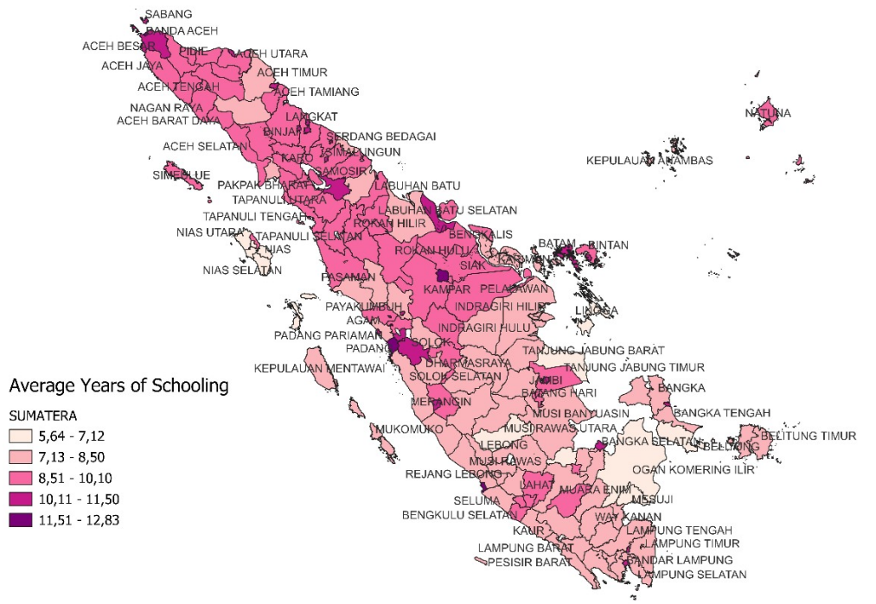
Figure 1. Figure Name Uses Times New Roman (Bold, 10 pt. font size, Capitalize Each Word)
Figures with more than one image ((a), (b), (c), …) must have the captions in a table with no border lines such that it is properly aligned to the center of each image. An example of how figures with more than one image should be styled in the manuscript is given in Figure 2, below:
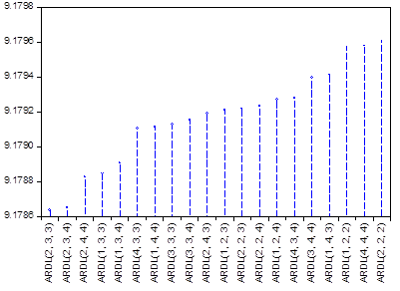
(a) | (b)
Figure 2. Figure Name Uses Times New Roman (Bold, 10 pt. font size, Capitalize Each Word)
(a)…………, (b)…………
References that use figures, tables, theorems, or lemmas, must be preceded by a capital letter without a dividing point, for example, “Figure 1 and Table 1 are illustrations of Theorem 1”. Tables and pictures must be placed in the body text and meet the standards for printing. Images do not need to be framed.
The following template provides the recommended format for writing and presenting algorithms in this paper.
Algorithm 1. RSA Algorithm
Input: Distinct large prime numbers, p and q.
Output: Private Key (d)
Public Key (e and n)
1: | Compute $n=pq$ and $ϕ\left(n\right)=\left(p-1\right)\left(q-1\right)$
2: | Choose a large integer e that is relatively prime to $ϕ\left(n\right)$, where $1<e<ϕ\left(n\right)$
3: | Calculate an integer d from the quotient $ed≡1 \left(mod m\right)$, which means  $d=\frac{1+k ϕ\left(n\right)}{e}$
4: | Return d, e, n

CONCLUSION
The conclusion should address the research problem and objective. State the importance of the research and the implications. Do not recapitulate the results but make statements, and use compelling statements, avoiding the word “maybe”, “perhaps”, etc. Write the conclusion of your manuscript in a narrative/paragraph form if there is only one concluding statement, or give numbering if needed.

Author Contributions
CRediT (Contributor Roles Taxonomy) Authorship Contribution statement is introduced to recognize individual author contributions, reduce authorship disputes, and facilitate collaboration. CRediT allows author to share an accurate and detailed description of their diverse contribution to the published work. The corresponding author is responsible for ensuring that the descriptions are accurate and agreeable by all authors. The role(s) of all authors should be listed using the relevant above categories. Authors may have contributed in multiple roles. Credit in no way changes the journal’s criteria to quality for authorship. CrediT statement should be provided during the submission process.
Possible CRediT statements:
Conceptualization, data curation, formal analysis, funding acquisition, investigation, methodology, project administration, resources, software, supervision, validation, visualization, writing-original draft, writing-review & editing.
Sample CRediT author statement:
First Author: Conceptualization, methodology, writing-original draft, software, validation. Second Author: Data curation, resources, draft preparation. Third Author: Formal analysis, validation, Fourth Author: Software, visualization. Fifth Author: Validation, writing-review & editing. All authors discussed the results and contributed to the final manuscript.

Funding Statement
The authors need to specify any sources of funding (institutional, private, and corporate financial support) who contributed to the article. This information, in the form of the name of the funding organization/s and the grant number or should be included at the end of the article under the heading ‘Funding’, and provided at the time of submitting the paper. If there was no funding, the following wording should be used: “This research received no specific grant from any funding agency in the public, commercial, or not-for-profit sectors.”

Acknowledgment
If there are any, write the acknowledgment or appreciation in this section. Acknowledgments can be addressed to those individuals, institutions, and laboratories who provided help during the research (e.g., providing language help, writing assistance or proof reading the article, reviewers, etc.). It could be also to people who contributed to the article or data in the article (excluding the authors).

Declarations
A conflict of interest, also known as a competing interest, is a situation in which an interest or connection -direct or indirect-could influence your research.
Example:
Competing interest. The authors declare no competing interest.
Conflict of interest. The authors declare that he/she has no conflicts of interest to report study.
Declaration of Generative AI and AI-assisted technologies
Possible option of AI-statements can be used by authors:
Generative AI tools (e.g., ChatGPT) were used solely for language refinement (grammar, spelling, and clarity). The scientific content, analysis, interpretation, and conclusions were developed entirely by the authors. The authors reviewed and approved all final text.
The authors used generative AI (ChatGPT) only to assist with language polishing and formatting consistency (e.g., improving wording and ensuring uniform terminology). No AI was used to generate research content, perform analyses, or create/modify figures and tables. The authors reviewed the manuscript in full and remain responsible for its content.
The authors declare that no generative AI or AI-assisted technologies were used in the preparation of this manuscript, including for writing, editing, data analysis, or the creation of tables and figures.

REFERENCES
To write references you should use the reference writing tools, such as Mendeley Reference Manager to reduce bibliography writing errors. The title size of "REFERENCES" is 11 pt. while the reference content size is 9 pt. The number of references is obtained from national and international scientific journals in the last 10 years (relevant and up to date). References from books are allowed but it is recommended from scientific journals. Reference sources that come from the internet web / blog are avoided as much as possible. The type of reference writing style uses the IEEE style (complete writing can be seen on the OJS website of the BAREKENG: Journal of Mathematics and Its Applications Reference Management section). The minimum number of references is 20 references, except for articles on Algebra and Analysis, by which the minimum number of references is 15 references. All references should be to the most pertinent and up to date sources (80% of references must be taken from the past 10 years).

- Example of writing reference from a Journal
[##] Author(s), “TITLE OF ARTICLE,” Journal name, vol.#, no.#, page, month and year.
Example:
[1] S.K. Kenue, “LIMITED ANGLE MULTI-FREQUENCY DIFFRACTION TOMOGRAPHY,” IEEE Trans. Sonic Ultrason, vol. SU-29, no. 6, pp. 213-217, July 1982. doi: https://doi.org/10.1016/j.jbusres.2024.114701.
[2] W. Chmielarz, M. Zborowski, J. Xuetao, M. Atasever, and J. Szpakowska, “COVID-19 PANDEMIC AS SUSTAINABILITY DETERMINANT OF E-COMMERCE IN THE CREATION OF INFORMATION SOCIETY,” Procedia Comput. Sci., vol. 207, pp. 4378–4389, 2022, doi: https://doi.org/10.1016/j.procs.2022.09.501.
- Example of writing reference from a Book
Whole book
[##] Author(s), TITLE OF BOOK, Edition (if any), Place of Publication: Publisher, Year. Example:
[3] P.M. Morse and H. Feshback, METHODS OF THEORETICAL PHYSIC. New York: McGraw Hill, 1953.
Part of the book
[##] Author(s), “TITLE OF PART,”, Title of book, Edition (if any). Place of Publication: Publisher, year, page.
Example:
[4] P. S. Meszaros, S.Lee and A. Laughlin, “INFORMATION PROCESSING AND INFORMATION TECHNOLOGY CAREER INTEREST AND CHOICE AMONG HIGH SCHOOL STUDENTS,” Reconfiguring the Firewall, Wellesley: A K Peters, 2007, 77-86.

Books Published by Agencies or Institutions
[5] World Bank, Information and Communication Technologies: A World Bank group strategy. Washington, DC: World Bank, 2002.
- Example of writing references from Proceedings
Published Conference articles in Proceedings
[##] Author(s), “TITLE OF ARTICLE”, Title of Proceeding, page, date of seminar event, year.
Example:
[6] R. Frinkel, R. Taylor, R. Bolles, R. Paul, “AN OVERVIEW OF AL, PROGRAMMING SYSTEM FOR AUTOMATION,” in Proc. Fourth Int. Join Conf Artif.Intel., pp. 758-765, Sept. 3-7, 2006.
Unpublished Conference articles in Proceedings
[7] H. A. Nimr, "DEFUZZIFICATION OF THE OUTPUTS OF FUZZY CONTROLLERS," presented at 5th Int. Conf. on Fuzzy Systems, 1996, Cairo, Egypt. 1996.
- References from websites
[##] Author (s), “TITLE OF DOCUMENT,” Title of website or owner, Year of publication. [Online]. Address: URL [access on date, month, year].
Example:
[8] B. Paynter, “ROBODINOS: WHAT COULD POSSIBLY GO WRONG?”, Wired, 20 Juli 2009, [Online]. available: http://www.wired.com/entertainment/magazine/17-08/st_robotdinos [Accessed: 25 Juli 2010].
- References from thesis or Dissertations
Unpublished Thesis
[9] M. W. Dixon, "APPLICATION OF NEURAL NETWORKS TO SOLVE THE ROUTING PROBLEM IN COMMUNICATION NETWORKS," Ph.D. dissertation, Murdoch Univ., Murdoch, WA, Australia, 1999.
Thesis Published in Online College Database
[10] F. Sudweeks, DEVELOPMENT AND LEADERSHIP IN COMPUTER-MEDIATED COLLABORATIVE GROUPS. PhD [Dissertation]. Murdoch, WA: Murdoch Univ., 2007. [Online]. Available: Australasian Digital Theses Program.

